Corporate Equality Objectives

Annual Progress Report
2016/17

Meeting the Public Sector Equality Duty

Foreword

Welcome to the latest Annual Equalities Progress Report which outlines our performance against our Corporate Equality Objectives for 2016/17. This Report highlights our performance and work towards advancing equality of opportunity, and helps evaluate the equality of our service provision. It also considers whether that work is benefitting our local communities and looks at ways we have worked to eliminate unlawful discrimination and promote good relations between the different communities that make up Harrow. The Report includes a number of case studies illustrating the wide range of work carried out by the Council which contributes to making a difference for the vulnerable; for communities; for families and for local businesses.

Equality is about describing a vision for the area that is built on recognising the needs of every local community, promoting inclusion and cohesion, fairness and justice. Harrow prides itself in being one of the most ethnically and religiously diverse boroughs in the country with people of many different backgrounds and life experiences living side by side. As a community leader, we will continue to work in partnership with the public, voluntary and private sectors to ensure we achieve this vision for our borough.

The Council operates a robust approach to the governance and mainstreaming equality and diversity across the organisation. Our Corporate Equalities Group (CEG), chaired by a Corporate Director provides senior leadership and strategic direction for developing and implementing excellent equality, diversity, cohesion and human rights policy development, practice and service delivery. The CEG works in collaboration with its partners to establish the business case for the equalities agenda in terms of service improvement, user involvement and customer satisfaction; and monitors equalities outcomes and progress. Each Directorate has in place a Directorate Equality Task Groups (DETGs) which forms a link between the CEG and Directorates. As well as playing a key role in championing equality, diversity and inclusion, promoting good practice on equality and diversity with regards to employment and service delivery, ETGs are tasked with ensuring that corporate equality commitments and objectives are translated into action. These actions are set out within this Annual Equalities Report.

Harrow is a vastly diverse Council, and there is so much being done across the Council to further equality and to celebrate the Borough’s diversity. The borough’s diversity is something to value and the Council can be proud of the achievements highlighted in this report, which build on our firm commitment to promote fairness and diversity, as outlined in our Corporate Plan. This Report also looks to highlight our continued commitment to maintaining and building on our strengths by ensuring equality and diversity are integral to everything we do.

This Report provides you with details of the progress we are making in achieving our equality objectives and our ambition towards this for the year ahead.

Introduction

Harrow is one of the most ethnically and religiously diverse boroughs in London with people of many different backgrounds and life experiences living side by side. It is the richness of this diversity, and the positive impact that it has on the borough and our community, that we believe helps make Harrow such a great place to live, work and visit. We know that the borough’s diversity is something to value and encourage and this Equality of Opportunity Policy highlights our commitment to maintaining and building on our strengths by ensuring equality and diversity is integral to everything we do.

In serving a diverse population, the Council aims to ensure there is equality of opportunity for its residents, service users, employees, elected members, stakeholders and partner organisations irrespective of age, disability, gender reassignment, marriage and civil partnership, pregnancy and maternity, race, religion or belief, sex and sexual orientation

However, we recognise that in our society, groups and individuals continue to be unlawfully discriminated against and we acknowledge our responsibilities to eliminate unlawful discrimination and to promote equality of opportunity and good relations within the rich diversity of Harrow's communities.

The Equality Act 2010 and the Public Sector Equality Duty (PSED)

The Equality Act 2010 introduced a new Public Sector Equality Duty (PSED) which requires public authorities, in the exercise of their functions, to have due regard to the need to:

- Eliminate unlawful discrimination, harassment and victimisation and other conduct prohibited by the Act;
- Advance equality of opportunity between people who share a protected characteristic and those who do not; and
- Foster good relations between people who share a protected characteristic and those who do not.

The PSED is supported by specific duties which are intended to help public authorities to meet its requirements.

The new PSED replaces the previous three Public Sector Equality Duties – for race, disability and gender and now covers the following protected characteristics:

- Age
- Disability
- Gender Reassignment
- Pregnancy and Maternity
- Race – this includes ethnic or national origins, colour or nationality
- Religion or Belief – this includes lack of belief
- Sex
- Sexual Orientation

It also applies to Marriage and Civil partnership but only in respect of the requirement to have due regard to the need to eliminate discrimination.
Public authorities covered by the specific duties are required to:

- Publish by the 31st January 2012 information to demonstrate their compliance with the general equality duty; and
- Prepare and publish by 6 April 2012, and at least every four years thereafter one or more equality objectives.

Our Corporate Equality Objectives

The Corporate Plan sets out the Council’s vision which is “Working Together to Make a Difference for Harrow”. To meet this vision, there are three corporate priorities that guide how the Council targets its resources and efforts:

Build a Better Harrow
Together we are building a better Harrow, for today, and for future generations, creating the places and the opportunities that all our residents deserve: a thriving, modern, inclusive and vibrant borough that makes Harrow a home to be proud of.

Be More Business-like and Business Friendly
We want to be seen as a council that understands the needs of local businesses, and supports them to grow and be successful. We also want to be seen as a well-run council, with our residents supporting our growing set of business ventures. We want our commercial services to be profitable and used by local residents and businesses, so the profits can then be re-invested back into those services most valued by our residents.

Protect the Most Vulnerable and Support Families
We want to make sure that those who are least able to look after themselves are properly cared for and supported. We want to safeguard adults and children from abuse and neglect, keep them safe and ensure they have access to opportunities and a good quality of life.

We have adopted a new Equalities vision, which was adopted by Cabinet. This vision is “A Proud, Fair & Cohesive Harrow, a Great Place to Live, Work & Visit”. In order to achieve this vision we have three Corporate Equality Objectives as set out in the ‘Harrow Council Corporate Plan 2015-19, which are:

- An inclusive workforce that feels valued, respected and reflects our community

- An improved understanding of our communities to ensure that services are fair, equitable and accessible to all and reduce inequality

- Promote and celebrate the diversity of our borough and foster community cohesion

Our Commitment

Equality is about describing a vision for the area that is built on recognising the needs of every local community, promoting inclusion and cohesion, fairness and justice. As a community leader, we will continue to work in partnership with the public, voluntary and private sectors to ensure we achieve this vision for our borough.

As an employer, we are committed to employing a diverse workforce, to help us to understand and relate to the community we serve. Through our recruitment policies and practices, we will aim to improve on our record and explore further initiatives and opportunities to encourage applicants from all sections of the community to consider joining us.

As a service provider, we are committed to ensuring our services are open, fair and accessible by taking into consideration the needs and requirements of our diverse community and service users. We will continue to improve our services through a comprehensive Equality Impact Assessment (EqIA) process, engaging with and listening to our communities and service users.

As a procurer of goods and services, we will continue to ensure our commissioning processes are fair and equitable and that service providers delivering a service on our behalf share our commitment to equality and diversity.

Reviewing Progress & Setting Priorities

The following section of this report outlines Harrow Council’s progress in 2016/17 against the Corporate Equality Objectives. As well as reporting our overall performance (Appendix 1) it includes a number of case studies to demonstrate how we have used monitoring data to identify a need, engage with our communities and address the needs through initiatives and projects to improve our services.

One of the ways progress can be measured is whether we achieved the performance targets that we set ourselves. The following section provides an overview of how many of the performance indicators associated with each Corporate Equality Objective were Green, Amber and Red, using the following criteria:

High Green: Target exceeded by more than 5%
Low Green: Target Met
Amber: Target missed by no more than 5%
Low Red: Target missed by 5-10%
High Red: Target missed by over 10%

Each Equality Objective has been given an overall ‘RAG’ status using the following criteria:

If two thirds of the indicators within a priority are a particular status then this will determine its status. If not, then the priority status will become Amber.

Objective 1: An inclusive workforce that feels valued, respected and reflects our community

Green | 3
Amber | 2
Red | 4
Overall Status | A

Key Highlights:

- The Council achieved 153rd position in Stonewall’s Workplace Equalities Index and was confirmed as the most improved organisation
- An improved SAP system which enables staff to enter their social identity
- Staff awards held to celebrate work that has taken place to embed equalities values and diversity
- Leadership development promoted to under-represented groups

In making Harrow a workplace that reflects the diversity of the borough and feels value and respected, we made a commitment to ensure we were able to develop a comprehensive profile of the workplace by improving the reporting and recording of protected characteristics. In doing so we also need to ensure we have a comprehensive profile of the workforce by improving the reporting and recording of protected characteristics, particularly disability, which has involved updating the SAP system to now allow staff members to include their social identity. All staff are also required to complete a mandatory Equality Matters training every two years to ensure that they are up to date with the latest legislation, Council policies and best practice.

Across the Council the proportion of BAME employees in lower pay bands is greater and reduces in higher pay bands. The representation of employees who have declared a disability remains low across all pay bands in the organisation. In line with this, there has been a commitment to improve the pathways to senior pay bands for BAME and disabled staff and to promote opportunities to increase the talent pipeline from under-represented groups. In doing so, members from our Corporate Leadership Group have committed to volunteer to be promoted as role models and leadership development continues to take place through coaching and CMI Management and leadership development.

Last year we also made a commitment to improve the recruitment, support and retention of young people in the Council. Last year only 3.83% of Council staff were made up of people aged 25 or under. This has now increased slightly to 4.28%, which is a 0.45% increase since the previous year. In addressing this issue, 55 young people have been supported through the X16 programme, which aims to improve the employability of young people who are not in education, employment or training (NEET). We have also worked with One Stop Shop and schools to promote apprenticeships.

This is not only limited to the Council workforce, but also throughout the borough. One example of this is through the Xcite Work Programme that provides professional information and advice, coaching, CV writing and confidence building to residents who want to get back into work.

In relation to staff mandatory equalities matters training we are aware that uptake is significantly low due to the fact that many staff at the depot do not have access to computers. For quarter 4 (36% of new starters, and 63% of existing staff) However, L&D are now working with all services to ensure staff receive this training in alternative ways, such as classroom based training. In Quarter 2 (2017/18) this increased to 55% for new starters and 71% for existing staff. This has shown a marked improvement.

Xcite Work Programme

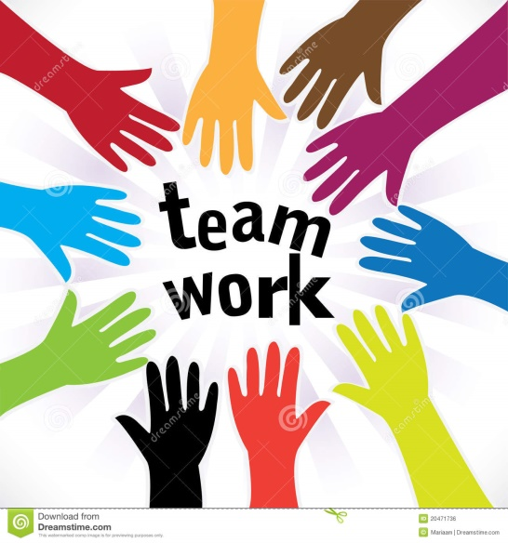

Mr. AA had been unemployed for six years and was unable to get an interview for a job. We arranged confidence building and 1-2-1 support to build his confidence. His Adviser discussed his options, which needed to fit around his childcare responsibilities. We arranged an interview with the council’s facility management supplier, and Mr. AA was successful in his application. Mr. AA said “the future seems brighter, at least now I can care for my children properly.”

Ms. D, single mother of two children aged 19 years and 10 years. The family became known to Harrow Children and Family Services via Harrow Jobcentre Plus (JCP), through a direct referral to the Multi Agency Safeguarding Hub (MASH) Team. Ms D had fled from Domestic Violence with support from her two children.

Ms. D had a language barrier, very low self-esteem, and was low in confidence. She had never been allowed to go out of the house or deal with finances, and had no bank account under her own name. She was supported to claim JSA, and tax credits and Child Benefits were also transferred to her name. She was taken to the Harrow Women’s Centre to speak to a legal adviser and an Independent Domestic Violence Advocate, and also to the Women’s Circle Faith Regen in Wembley for counselling support.

Her Adviser then contacted care agencies to see if they had any homes that spoke the same language as her, where she could do care work. We arranged for her training and a DBS, and she was offered a job. We contacted tax credits to find out how much she would be entitled to, and did a “Better off” calculation which showed that she was better off taking this job.

Ms D is now working 20 hours per week, earning £8 per hourand receiving £139 in tax credits, where she was only getting JSA of £72pw. She is much more confident and looking to increase her working hours and learning to drive. She said her “life has turned around completely”.

In relation to Lesbian Gay Bisexual Transgender (LGBT)staff in particular, our target at the beginning of the year was for Harrow to become a more inclusive workplace for LGBT staff and members and to achieve a top 200 place in the Workplace Index in 2016. Achieving 153rd position in the Index has been a huge success for the Council and we pledge to build on this success in the coming year.
Stonewall

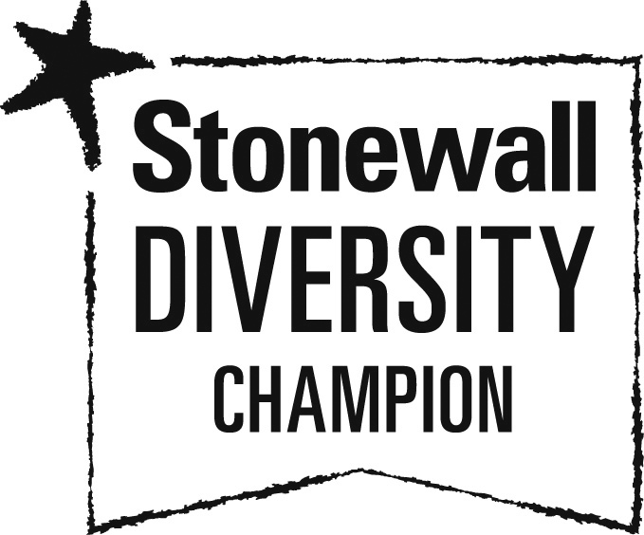

As part of our commitment to promote equality of opportunity and to help develop ‘an inclusive workforce that feels valued, respected and reflects our community’, Harrow Council signed up to Stonewall’s Diversity Champions Programme in 2015. The programme enabled us to build on our work around LGBT equality and ensured we support our staff and service users who identify as LGBT.

As part of the programme, we submitted evidence to participate in Stonewall’s Workplace Equality Index (WEI). The WEI is a powerful evidence-based benchmarking tool used by employers to assess their achievements and progress on LGBT equality in the workplace. In 2015 we were ranked 399 out of 416 employers, which highlighted, although we had come a long way, there was still much more to do. The Corporate Equalities Group (CEG) set a target to get into the top 200 in 2016.

This year Harrow progressed to 153rd place out of 440 employers, this is huge successSome of the initiatives this year included, LGBT awareness training, Rainbow stickers, LGBT history month, International Day Against Homophobia, Biophobia, and Transphobia (IDAHO), and taking part in the London Pride March.

Objective 2: An improved understanding of our communities to ensure that services are fair, equitable and accessible to all and reduce inequality

Green | 2
Amber
Red | 2
Overall Status | A

Key Highlights:

- Harrow’s frontline staff who work in Access Harrow are now trained in British Sign Language
- A communications plan was developed and the service has been publicised in the CEO Newsletter, internal communications and staff updates. A press release was also issued and the service was publicised via social media. In 2015/2016 there were 8,832 Disabled Go users, this increased to 15,511 in 2016/ 2017.

Last year this report highlighted that data against some of the protected characteristics is not collated. There are also cases where the data is not fully analysed. Feedback showed that frontline staff often felt uncomfortable requesting such information from service users. We made it a priority to review and update all our data collation systems to collate data on all nine protected characteristics and update the complaints reporting procedures to capture diversity monitoring information. This work has begun but due to the replacement of the CCPH/CRM system we cannot provide a date of completion as the project is yet to be determined with Sopra Steria. We also made a pledge to incorporate diversity monitoring into the My Harrow Account.

We also continue to make improvements in the organisation as contained in the British Sign Language (BSL) Charter. The Charter pledges to improve access for deaf people to local services and information, and promote learning and high quality teaching of BSL (including giving all deaf children the option of bilingual BSL). We are ensuring staff that work with deaf people meet the minimum standards of BSL and consult with our local deaf community on a regular basis. Earlier this year we received feedback that more could be done to publicise the Access Guide to increase its usage. We took this on board and undertook a publicity campaign to promote the Access Guide, a communications plan was developed and all forms of social media publicity were implemented in order to increase the number of people who use the Access Guide.

BSL Access Harrow training
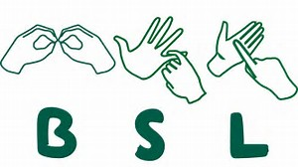

Access Harrow has successfully trained 10 customer service Advisers in British sign language; this has been achieved over the last decade. This training has served as a motivator to staff as well as ensuring that the council is able to deal with residents and customers within the deaf community. We have found that the level of training has helped to maintain a high level of customer service that is inclusive to all. It is well received by our customers and residents who need to use our frontline services.

We have also made improvements for disabled residents in the borough through Disabled Go, which provides important access information to local cinemas, restaurants, shops, pubs, etc., allowing people the freedom to decide whether these places are accessible and if they have facilities such as a hearing loop or text in large print.

Disabled Go

Founded by Gregory Burke, a wheelchair user, DisabledGo is the product of years of extensive research and consultation with disabled people and organisations. Developed by disabled people for disabled people, DisabledGo empowers you to make direct, anonymous enquiries about particular venues and judge whether they will be accessible to your individual needs.

Objective 3: Promote and celebrate the diversity of our borough and foster community cohesion

Green | 2
Amber
Red | 1
Overall Status | G

Key Highlights:
- Organised a successful suite of diversity events including Black History Month, International Women’s Day, LGBT History Month, Interfaith Week and entering a walking group of twenty six staff and members at Pride in London in 2016
- Over a thousand people have been given WRAP (Workshop to Raise Awareness of Prevent) training

In the last Report we wanted to undertake a feasibility study to establish a borough wide Diversity Network with statutory partners. This would consist of organisations across Harrow in order to share best practice, skills and experience to proactively promote diversity and community cohesion within the borough. However, it has been difficult to progress this further due to capacity and resource pressures faced by statutory partners. For 2017/18 we propose building on the knowledge and networks of existing community groups and formalising this relationship in order to share best practice and promote diversity and community cohesion within the borough.

In July 2016, the Council participated in Pride in London, and entered a walking group of twenty six in the march for the very first time. In addition to this, a successful LGBT programme of events has been agreed and launched.

Celebrating LGBT History month

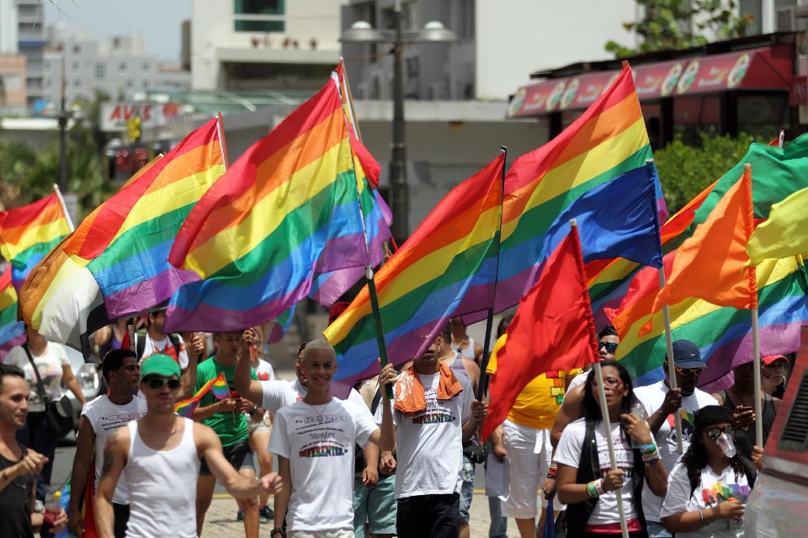

In February this year the Council officially celebrated LGBT History Month. The event featured a screening of the film ‘Carol’, stalls and talks, including from Tony Fenwick from Schools Out UK, the organisation that founded LGBT History Month in the UK.

Celebrating Black History month

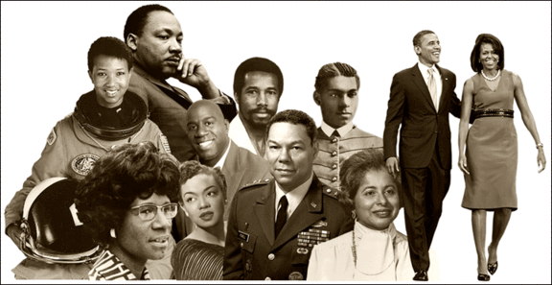

In Harrow we proudly celebrate Black History month. The event was launched by the Chief Executive and Councillor Varsha Parmer, portfolio holder for equalities, who talked about the personal impact of inspirational figures such as Nelson Mandela, Michael Jackson and Martin Luther King. Black History Month was an opportunity to remember those who have fought for a more equal and progressive society. It was also a great opportunity to learn more about the rich history and heritage of the Afro-Caribbean community. Thanks to the Making a Difference Group, Council staff enjoyed a wide range of BHM events – with a focus on Black British Music, which included wonderful performances by staff group, Ellensi, a debate facilitated by Social Rights activist, Toyin Agbetu and a fun, interactive quiz about Black role models.

Appendix 1 – Corporate Equality & Diversity Performance Targets 2015/16

Measure | Target  2016/17 | Actual  2016/17 | RAG Status | Comments (include comparisons against National Average and Neighbouring Borough(s) where available)
Objective 1: An inclusive workforce that feels valued, respected and reflects our community
Improve on our position in Stonewall’s Workplace Index (WI)  - KPI – Achieving a top 200 place in the workplace index in 2016 | 200 | 153 | HG | The Council achieved 153rd position in the WEI and was confirmed as the most improved organisation.
Achieve a more comprehensive profile of the workforce by improving the reporting and recording of protected characteristics, particularly disability.  - KPI - % of staff providing social identify information | 23% | 24.4% | HG | SAP has been updated for staff to be able to enter their social identity. Communications have gone out e.g “Whats it got to do with you” and also the newsletters to encourage staff to input their data.
- Programme to embed values is on-going.
- Staff awards were held to celebrate work against the values including work around Equalities & Diversity. Values also included as part of the appraisal where staff can update any work around equalities for the “do it Together” Value.
- Values E-Learning in development
Improve the proportion of BAME and disabled staff at senior pay bands  - KPI - Proportion of Black, Asian & Minority Ethnic (BAME) employees  - KPI - Proportion of disabled employees  - KPI - % of top 5% of earners who are BAME  - KPI - % top 5% of earners who are disabled | 45%  3%  20%  3% | 45%  2.2%  21.9%  2.86% | LG  HR  HG  A | The Chief Executive is responsible for driving the agenda supported by CLG who have committed to a series of actions to achieve the Priorities for the Objective of An inclusive workforce that feels valued, respected and reflects our community.
 |  |  |  | CLG members from under-represented groups have committed to volunteer to be promoted as role models.
 |  |  |  | Leadership development continues to be promoted to staff from under-represented Groups. Most recently our Coaching and CMI Management & Leadership Programmes
 |  |  |  | Work to monitor application of the performance appraisal scheme to ensure there is no indication of bias will commence following half year review.
Improve the recruitment, support and retention of young people  - KPI - Proportion of Harrow Council employees aged less than 25 | 3.31% | 2.62% | HR | Review of policy ongoing as part of the Recruitment project.
303 young people supported into work in 2016/17
55 young people have been supported through the X16 programme.
All staff to complete the mandatory Equality Matters training every two years to ensure they are up to date with the latest legislation, Council’s policies and best practice.  - KPI - % of new starters who completed the mandatory Equality Matters training (either face to face or E-Learning Module) within the first 8 weeks of their employment  - KPI - % of existing staff (as at April '16) who are up to date with Equality Matters refresher training (either face to face or E-Learning Module) | 100%  100% | 36%  63% | HR  HR | Q3 – 58% of all staff have completed the Equality Matters training (if we exclude staff that don’t have access to a computer, predominantly at the depot, then this rises to 87%). L&D are working with Managers to arrange Classroom training where staff do not have IT access.  Quarter 4 results are better at:  - KPI - % of new starters who completed the mandatory Equality Matters training (either face to face or E-Learning Module) within the first 8 weeks of their employment 55%  - KPI - % of existing staff (as at April '16) who are up to date with Equality Matters refresher training (either face to face or E-Learning Module) 71%
Objective 2: An improved understanding of our communities to ensure that services are fair, equitable and accessible to all and reduce inequality
Review and strengthen monitoring systems across the council to ensure a consistent approach to collating and analysing diversity data to inform policy and service development | - | - | R | - Due to the replacement of the CCPH/CRM system we cannot provide a date of completion of the project to update all complaints reporting procedures to capture diversity monitoring information on all nine Protected Characteristics – this project is yet to be determined with Sopra Steria  - The cost of incorporating diversity monitoring into My Harrow Account is being investigated. To avoid additional cost, it was planned that this could be included in the CRM/CCPH upgrade, to be used as master data. The replacement of CCPH does not include complaints, so complaints will remain on SAP. If the change is required to SAP then a request from the policy team will need to be submitted to Sopra Steria to obtain costs and determine whether funding is available.
Continue to pursue the aspirations contained in the BSL Charter | - | - | A | The latest for Q4 is as follows:  Resources Fairer Working Group has considered this. Given previous work, which has included BSL trained staff in Access Harrow, work was also undertaken to understand whether there was any scope for Courts or Bailiffs services. It was concluded that it was the Courts’ responsibility to provide support for those who may need this type of support (which has not seen a request to date), and for Bailiffs, one of the two companies that we use has agreed to look into setting up some BSL provision.
DisabledGo – increase the number of people who use the Access Guide  - KPI - Number of hits on the DisabledGo site | 8,832 | 15,511 | HG | A communications plan was developed and the service has been publicised in the CEO Newsletter, internal comms and staff updates. A press release has also been issued and the service has been publicised via social media.
Attainment – Closing the gap  - KPIs – Attainment KPIs (See People Scorecard) | - | - | R | The closing the gap indicators will not be reported against until October 2017 or even Quarter 3 – due to the significant changes in reporting at KS2 & KS4.
Adult Learning  Development, delivery and evaluation of community learning programmes to support recovery from mental health problems  - KPI - % of adults in contact with secondary mental health services in paid employment | 6.5% | 9% | HG | 320 residents participants benefited from the Active Minds projects and entered learning provision
Adult Social Care - Given the changes taking place, ensure these do not adversely impact on Adult Social Care Services  - KPI – equality of service provision (Adult Social Care) | 0.9-1.1% | 0.99% | G
Objective 3: Promote and celebrate the diversity of our borough and foster community cohesion
Undertake a feasibility study to establish a borough wide Diversity Network | - | - | R | Until now there has been no capacity or resources within statutory partners who are integral to such a group for such a body, hence no further action is being taken in this reporting year. However, in future we will be looking to existing organisations and networks that work with the Council to formalise the good work that is already taking place.
Organise, deliver and celebrate key diversity events within the borough. Work in partnership with partners, stakeholders and the VCS to organise, deliver and celebrate the events  - KPI - % of residents who agree that people from different backgrounds get on well together in their area | 70% | 79% | HG | - The Council entered a walking group of 26 at this year’s London PRIDE on 25th June.  - Working with Age UK Harrow to mark International Day of Older People.  - Council has supported Harrow Interfaith programme of events, including a series of question time events.  - Hate Crime awareness events in partnership with the Police  - A successful LGBT programme of events has been agreed and launched.
Engagement – Deliver the engagement element of the Prevent action plan  - KPI - % of residents who agree that people from different backgrounds get on well together in their area. | 70% | 79% | HG | WRAP training being delivered, over 1111 trained in 15/16  Local channel arrangements established and promoted across partnerships and community leaders briefed  Safer Giving campaign messages widely circulated across the third sector, partners and faith sector  Halls for Hire recommendations and considerations actively promoted across the partnership, third sector and faith sector

